Lab 09a - Implement Web Apps

Task 1: Creating the web app resource

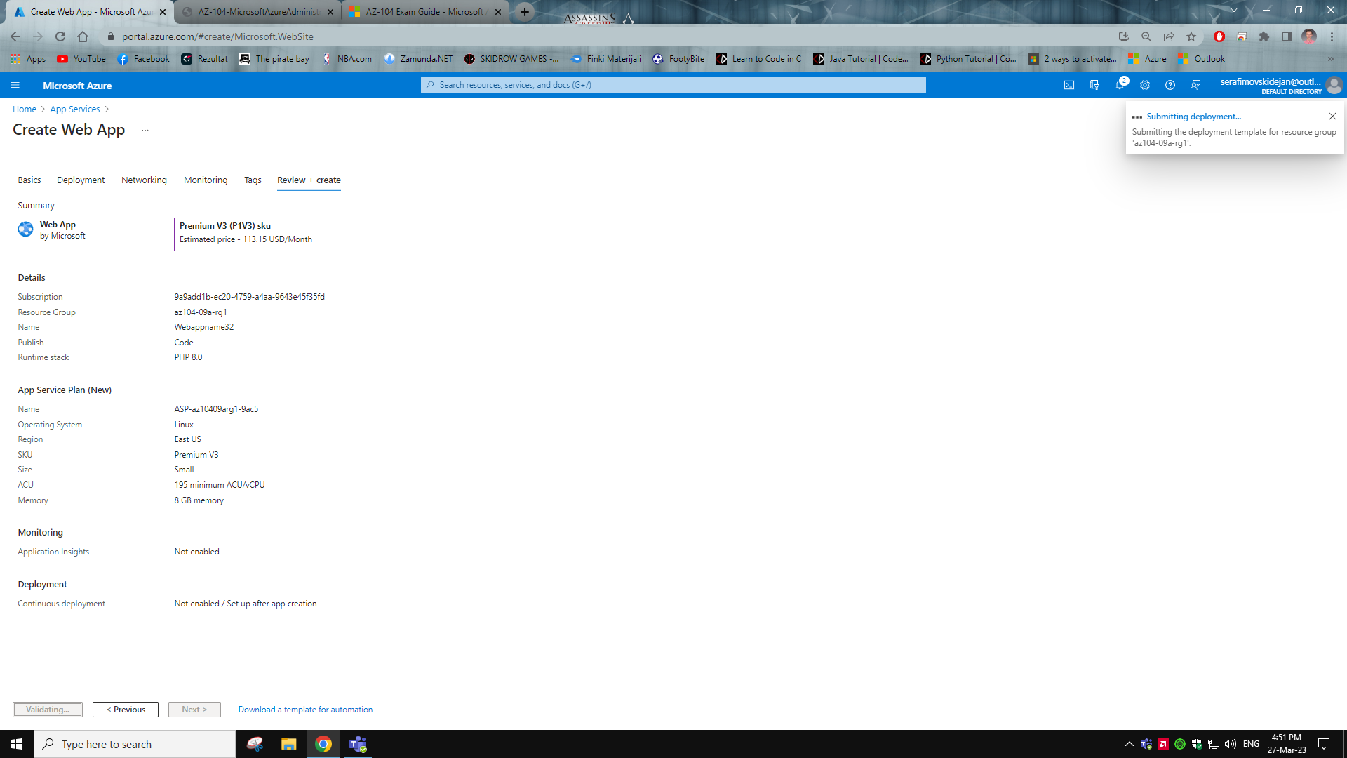

Task 2: Creating a staging deployment slot

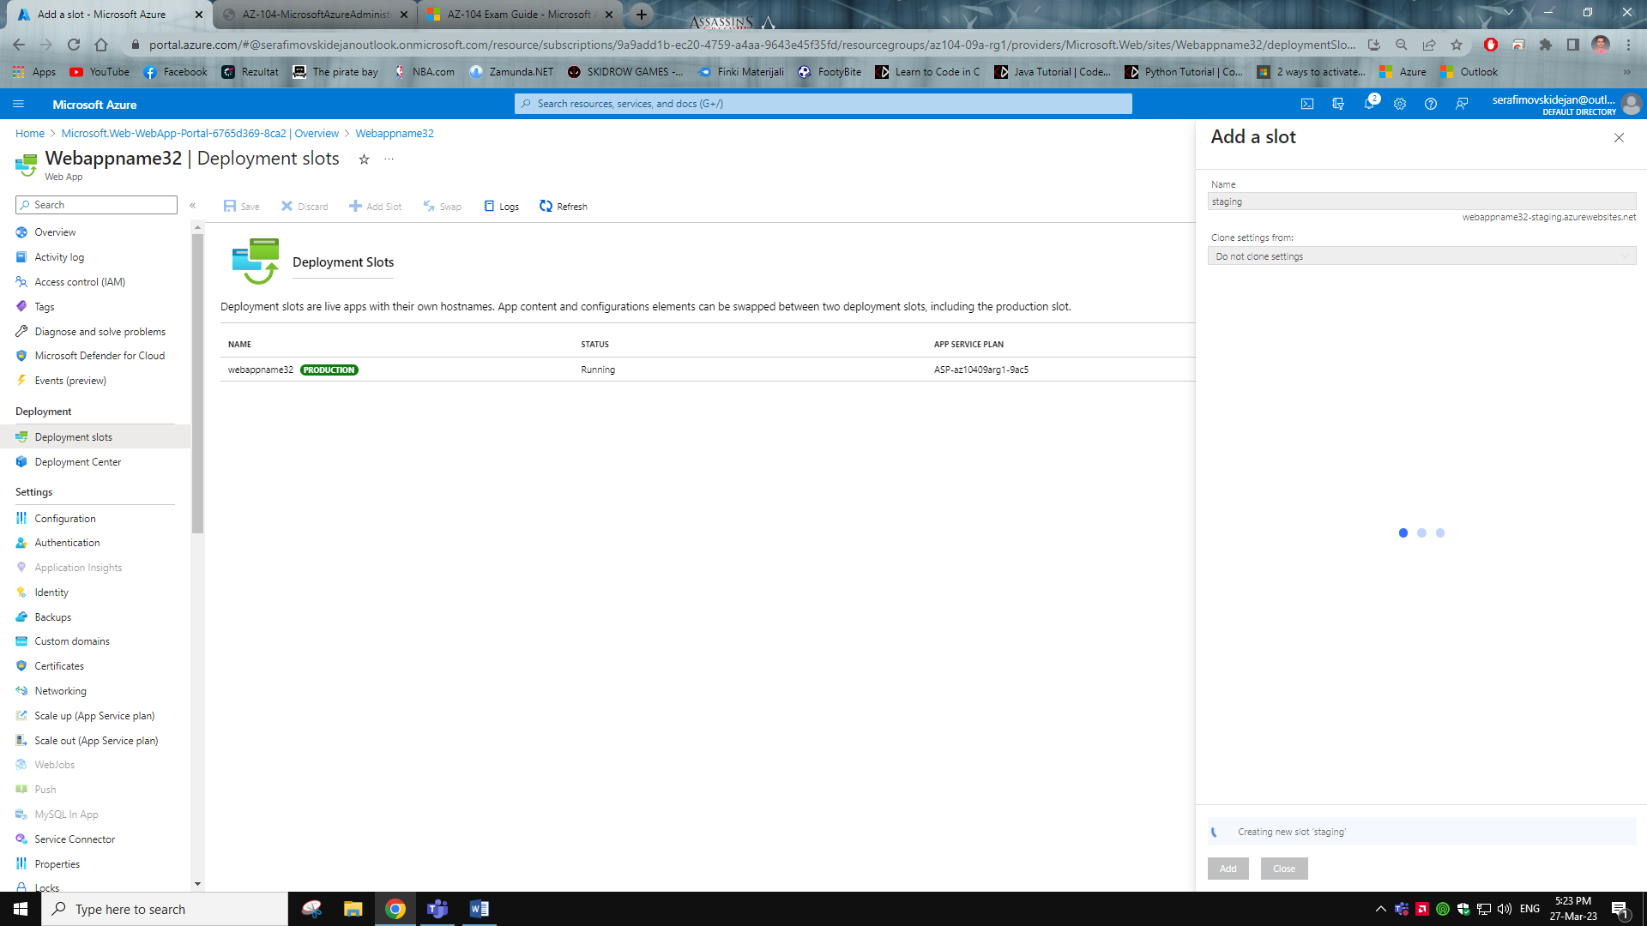

Task 3: Configure web app deployment using Local Git

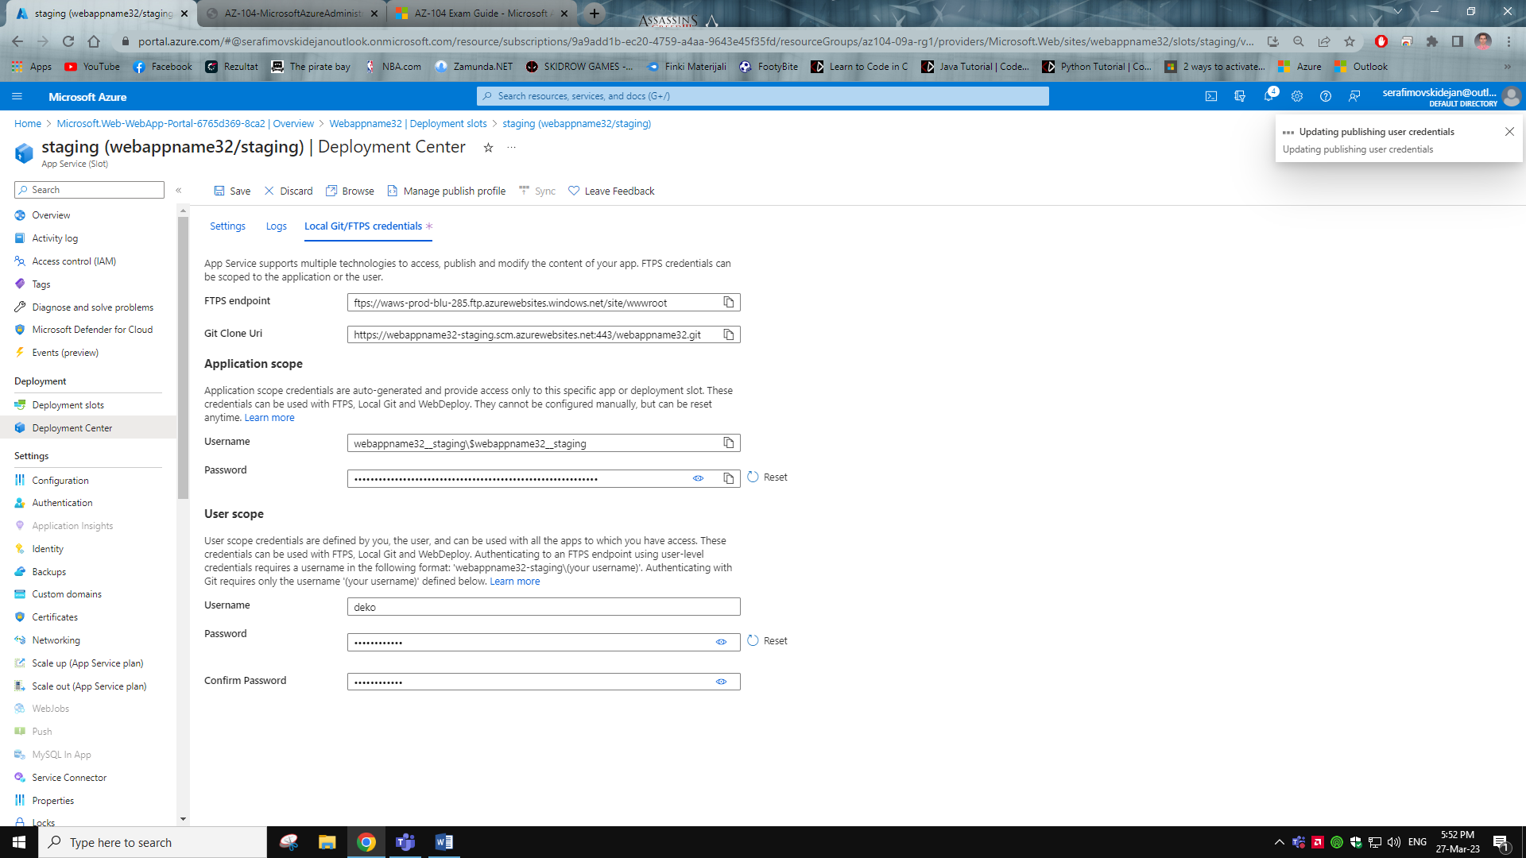

Task 4: Deploying code to staging deployment slot using git and Azure cloud shell

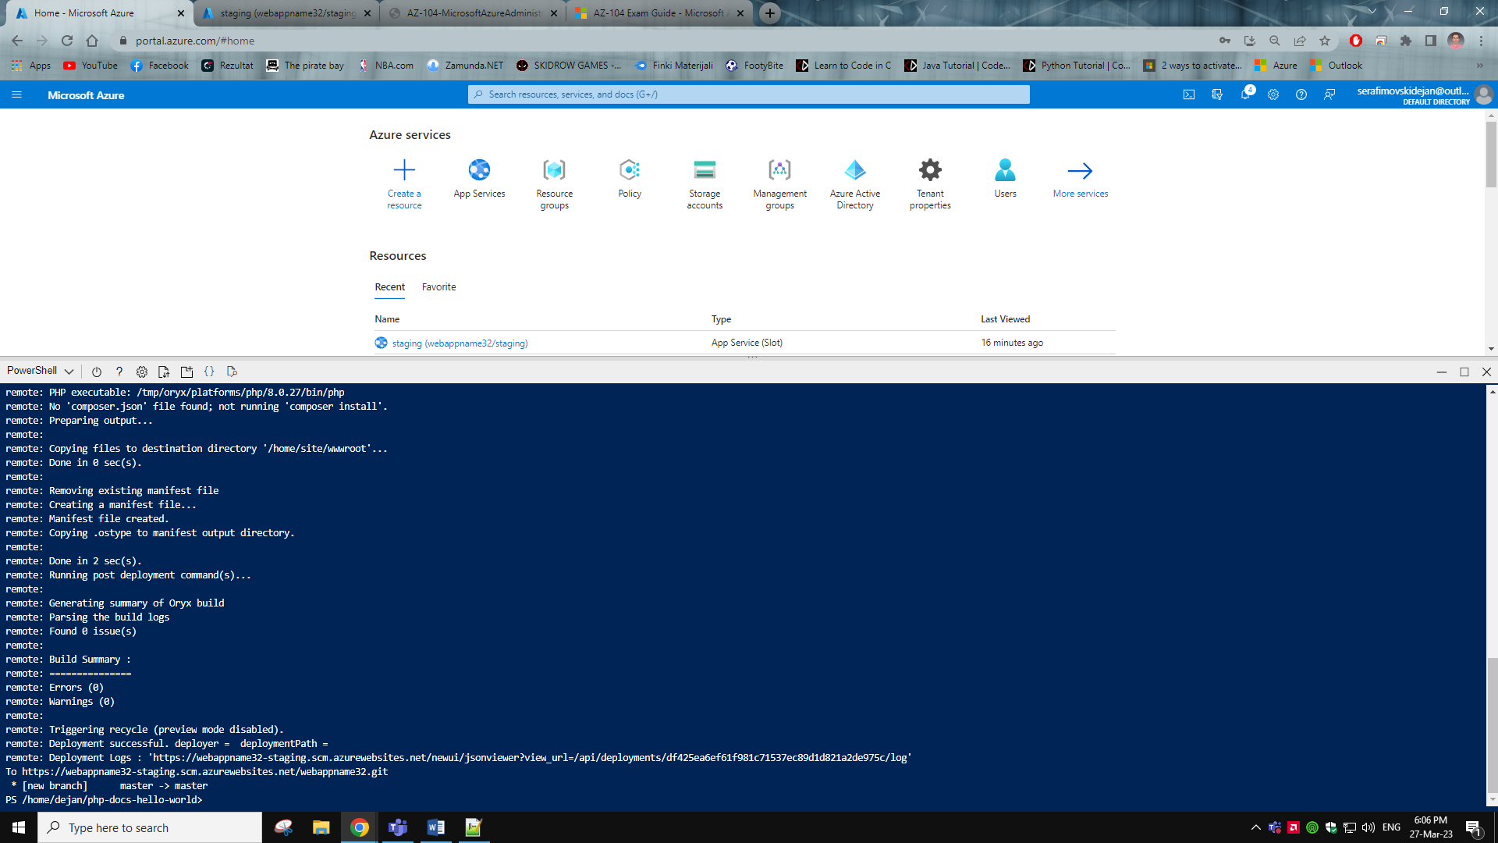



Task 5: Swapping staging slots



Task 6: Configuring and testing auto scaling of the Azure web app

